POSITION DESCRIPTION
Nga mahi o te tari kāwanatanga | Working in the Public Service
Our local government public service works collectively to make a meaningful difference for New Zealand communities. The purpose of all public service is to support our democracy, enable elected officials to develop and implement their policies, deliver high-quality and efficient public services, support Councillors to pursue the long-term public interest, facilitate active citizenship and act in accordance with the law. We have an important role in supporting the Crown in its relationships with Māori under the Treaty of Waitangi and te Tiriti o Waitangi. Whilst there are many diverse roles, all public servants are unified by a spirit of service to the community and guided by the core principles and values of the public service in our work.

The Position
Position: | Accountant
Group: | Corporate Services
Team: | Finance
Responsible to (Manager): | Chief Financial Officer
Responsible for (direct reports): | None
Job Purpose: | The Financial Accountant is responsible for running the accounting and financial activities of Council. They analyse the economic stability of the organisation and provides financial information to budget holders, enabling them to make budgeting and investment decisions.
Work location: | South Wairarapa District Council Buildings, Greytown
Employment type: | Permanent, Full time
Job grade: | TBC
Budget responsibilities: | None
Date prepared/reviewed: | April 2024

The Team
Role of the team
As part of the South Wairarapa District Council has responsibility for collecting, interpreting, and reviewing financial information, predicting future financial trends, reporting to management and stakeholders, and providing advice how Council and future business decisions might be impacted. Furthermore, the team produces financial reports related to budgets, account payables, account receivables, expenses and develops long-term business plans based on these reports. The team is also responsible for reviewing, monitoring, and managing budgets, developing strategies that work to minimise financial risk and analyses market trends and competitors.

Where my role fits within SWDC (organisational context)
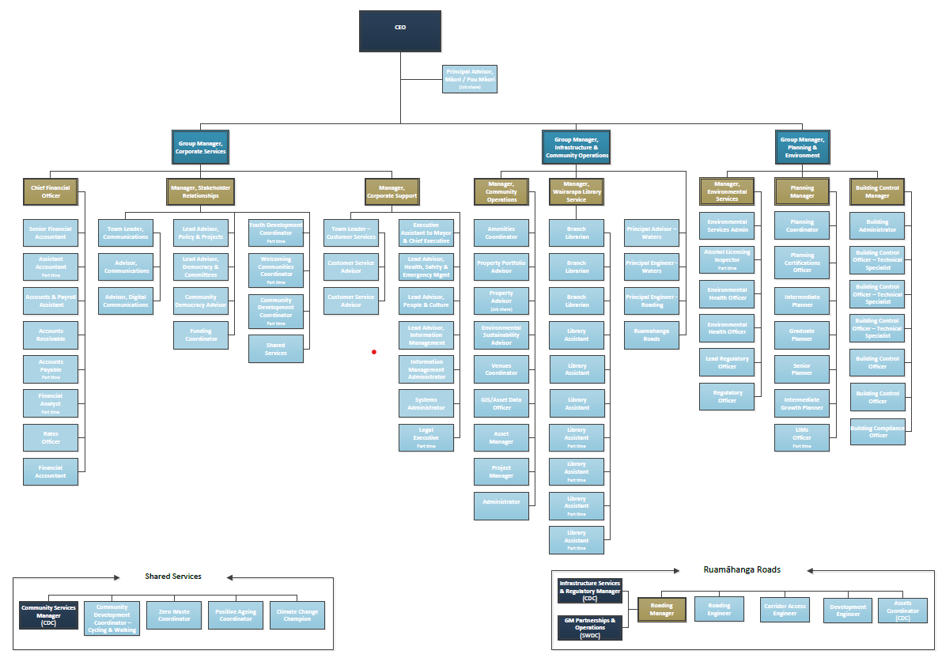

In order to ensure quality service delivery is provided, this position must have well developed relationships. These include but are not limited to:

Internal | External
Chief Executive  Strategic Leadership Team  Tier 3 Managers  Other Council staff  Mayor and Councillors  Community Boards and Committee members | Council stakeholders  Contracted service providers  Technical professionals in your field  Consultants and Contractors  Professional service providers  Auditors  The South Wairarapa community  Local Iwi groups  Neighbouring local authorities

Our Council
Our Vision: | For the South Wairarapa to be an open, energetic and unified community
Our Mission: | To be future focused, growth orientated and exercise sound judgement
Our values | We support our Mission and Objectives through living our values. These are:  - People first: Our staff, Te Tiriti o Waitangi partners and communities are at the heart of what we do. We practice respect and equality.  - Openness: We will be open in our mindset and transparent and timely in what we provide.  - Grow and learn: We listen, evolve and are open to new ideas.  - Trusted in delivery: We keep our word to deliver quality outcomes.  - Responsive and innovative: We adjust to new conditions and think outside of the box.  - Ka mua, ka muri: We look to the past to help inform where we need to go

Mō te tūnga | Role Overview
In your role as Financial Accountant, you will report to the Chief Financial Officer, and work in close partnership with other South Wairarapa District Council teams to provide delivery of high-quality financial services and establish a culture of service excellence throughout the organisation.
Outcomes | Actions
Delivery  Context:  - Financial accounting | - Delivery of specialist Financial Accounting services that actively support and contribute to the achievement of the Council’s outcomes and that deliver to the needs of the community and internal and external stakeholders.  - Deliver quality month end processes to support the attestation process across the general ledger and balance sheet requirements in line with task management assignments and meeting deadlines to facilitate reporting.  - Completion of accruals, and provision and prepayment entries on a timely and accurate basis and can be supported by robust calculations and assumptions which can be validated by supporting analysis.  - Detailed monthly General Ledger Balance Sheet reconciliations occur for all entities are provided to the Chief Financial Officer to review, and ensuring there is a robust process to clear outstanding reconciling items identified and that all balances are validated by supporting documentation.  - Confirmation processes are completed based on agreed timetables and audit requirements are met.  - Fixed asset registers are accurately maintained and there is an appropriate process in place to validate control, detail and existence of all individual assets owned and identified and ensure the accuracy of the overall register information.  - Lead process or system improvement project when required, provide support and cross cover to other members in the team.  - Answer and follow up the queries from the business or other teams.  - Regular view of General Ledger Balance Sheet balances across all entities to ensure that no impairment should be recorded, and all liability information is complete.  - Seek opportunities for continuous improvement in financial controls, reconciliation and month end processes and compliance, ensure all processes are documented through detailed process notes and that these are regularly. reviewed/updated.  - Work collaboratively across all of Finance and other Council teams to deliver quality outcomes.  - As business needs require it may be necessary for the role to perform duties of other members of the team in the Finance
Relationships | - Develop and maintain collaborative relationships with both internal and external stakeholders to foresee and resolve issues.  - To ensure that the Corporate Services Group and Council are always promoted in the best possible light by providing a superior customer service focused frontline.  - Maintain and develop a network of relevant contacts to ensure that communication channels are kept open.
Corporate Contribution | - Participate as a member of the SWDC Team, making a full contribution to team and organisational initiatives.  - Behave consistently with the SWDC Vision, Mission and Values  - Foster co-operation and aid communication between teams, units and groups  - Look for opportunities to improve systems, processes, and work practices – both within your own position and the organisation as a whole.  - Assist the organisation’s Emergency Management Unit in the event of a major disaster.  - Adhere to Health and Safety policies and standards and encourage all other staff to do the same.  - Attend appropriate courses to maintain ongoing knowledge and training.
Council Image | - Take every opportunity to promote a positive image of the Group and Unit and their activities.  - Contribute to the Group business plan.  - Represent the Group when appropriate at meetings.  - Provide information to customers and the public as supplied.

The key areas of responsibility above reflect the environment as it exists currently. They are not an exhaustive list and it is recognised that they will be subject to variation

Ngā āhuatanga e hiahiatia ana e Mātou | Person specification
Qualifications and Experience
- Tertiary qualification in Finance or a related field and/or equivalent experience
- Experience in the analysis and presentation of information.
- High level knowledge in the relevant legislation and successful track record.
- Advanced user of Microsoft suite
- Experience working within a legislative and regulatory framework.
- Experience initiating and leading change to achieve organisation goals.

Personal Capabilities
- Demonstrated ability to form and manage high performing teams with a strong customer focus.
- Ability to analyse issues, problem solve and maintain a positive disposition under pressure.
- A high-quality relationship manager that develops a strong internal and external network.
- Delivery focused and able to work autonomously and at pace across different tasks.
- Self-disciplined and organised enough to effectively manage a large and diverse portfolio.
- Can work closely with elected officials and appreciates the political context within which they operate.
- Works collaboratively with individuals and teams to achieve joint outcomes.
- Able to write and professionally present complex information to a range of audiences.
The Values by which we work
- People first: Our staff, Treaty Te Tiriti o Waitangi partners and communities are at the heart of what we do
- Open and transparent: Everything to give and nothing to hide
- Pursue growth and learning: Actively listening and evolving. Being open to new ideas
- Trusted to deliver: Making a difference, and bringing about quality outcomes
- Responsive and creative: Adjusting to new conditions and thinking outside of the box
- Ka mua, ka muri: (Walking backwards into the future). Look to the past to inform where we need to go
The Behaviours by which we work
All staff at SWDC share these responsibilities, including me.
- Collaborate: Draw on the knowledge of others to bring about better outcomes for the customer.
- Grow: Develop ourselves and maintain the highest possible standards of professionalism. Embrace feedback and build on it.
- Being: Act with integrity and maintain consistency. Be attentive and kind to one another and embrace different perspectives.
- Add value: Through our technical knowledge, deliver the best possible outcomes for our customers.
- Plan: Be clear on how activities link together and highlight any risks.
- Do: Keep people engaged in what we do and why. Hold ourselves to account for delivery as we do with others.
- Review: Learn from mistakes. Fail fast and move on. Seek out solutions not problems. Blame as no part in our organisation.
- Inspire: Empower, support, encourage, and motivate colleagues to do their best work.
- Connected: Build strong relationships with people and are respectful and empathetic.
- Positivity: Create an empowering, safe, and inclusive social environment. Foster a strong wellbeing culture.
- Engage: Consider when to communicate. Break things down into easily understandable chunks. Take a genuine and active interest in the organisation at large. Speak out when others behave in a manner not acceptable to the rest of us.
- Celebrate: Celebrate our achievements, both individually and as a collective

Amendments to Position Description
From time to time, it may be necessary to consider changes in the Job Description in response to the changing nature of our work environment – including technological requirements or statutory changes. Such change may be initiated as necessary by the manager of the position. This Position Description will be reviewed as part of the preparation for performance planning for the annual cycle. (A review in job size and possible impact on remuneration structure of the position will only be considered where change of the position is significant (guideline: significant would typically involve a 25% change in the complexity / accountability of the role.)

My Agreement
My Name:
My Signature:
Date:

