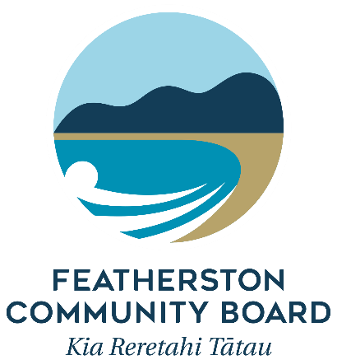

Funding Accountability Form

All recipients of funds from the Featherston Community Board (FCB) must complete this form within 12 months of the grant being paid out, or prior to any future grant application being made.

Please return the completed form to –
Committee Advisor (Grants)
South Wairarapa District Council
PO Box 6
Martinborough 5741
grants@swdc.govt.nz

- Funding for:

- Name of applicant:
- Location of project/funding

- Date of project/funding:

$
- Amount received from the FCB:

- Please give details of how the money was spent. Your contribution to the project and the FCB funding you received must be accounted for.
$
$
$
$
- Please provide details
about the project or activities that were supported by the FCB grant. Explain what was successful, and what didn’t work so well.
- Give a brief description
of the highlights of your project, including
the number of
participants.
- How did your project
benefit your community?

- What, if any, are the
next steps (for your project, for you and/or
for the people involved)?
Will your organisation continue to require funding?
- This report was completed by:
Name:
Address:
Date:
Phone:
Email:

