Concept Option Two – Intensification Around Main Street and New Town Centre Train Station
- Move the train station to the centre of town to help support main street rejuvenation and create a range of densities
- Located more to the south, this option also does not encourage the development of general or medium density development beyond the existing established boundaries
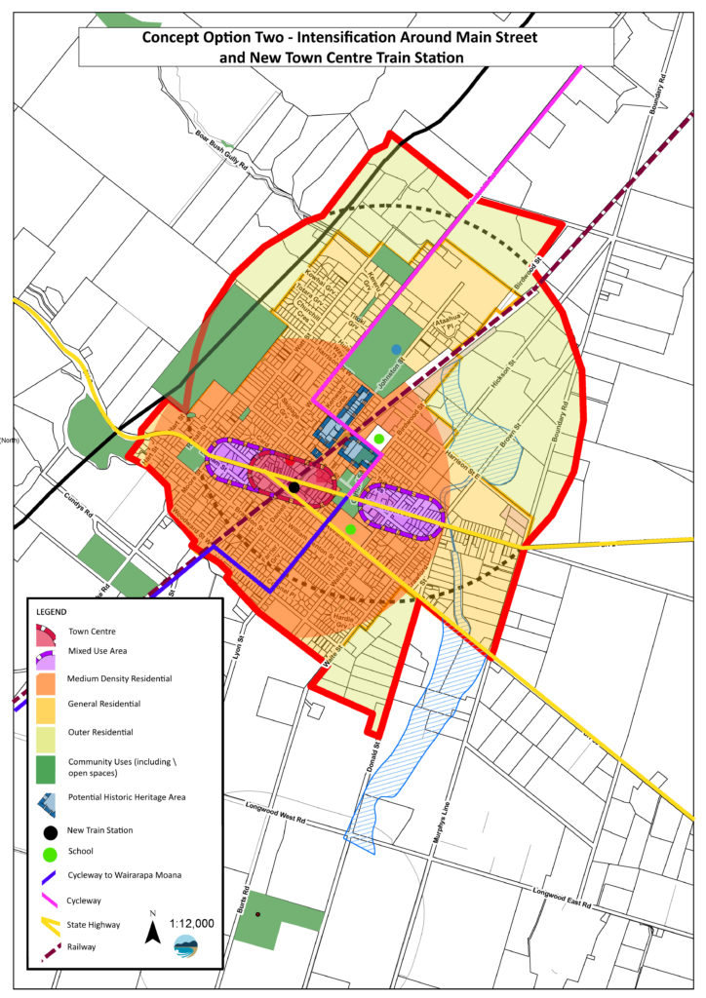
Both Concept Option Two and Concept Option One (which was selected) proposed minimum section sizes of 300 square metres in the “general” areas, and 200sqm in the “medium density” zones. This is a reduction of the minimum lot size in Featherston which is currently 500sqm but many sections are 800-900sqm and are unable to be subdivided.
Feedback from this consultation period will guide a draft Masterplan, which will go out to formal consultation in early 2023.

