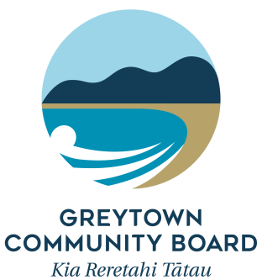

Funding Accountability Form

All recipients of funds from the Greytown Community Board must complete this form within 12 months of the grant being paid out, or prior to any future grant application being made.

Please return the completed form to –
Committee Advisor (Grants)
South Wairarapa District Council
PO Box 6
Martinborough 5741
grants@swdc.govt.nz
- Name of Organisation

- Project Name

- Date of Project

- Amount received from the Greytown Community Board
$

- Provide details of the project

- Was the money used exactly for the intended purpose as per your application? Please give details and reasons for any variation

- How did your project benefit the wider Greytown community?

- How many people or groups from the Greytown community were involved or benefited from your project? Please provide actual numbers of members living in the Greytown area (postal codes 5712, 5794 and rural families with Greytown as their home address). Please state this number versus the total number (e.g. 3 Greytown individuals versus 20 other Wairarapa individuals).

- Which sector does your organisation have an impact on (as per our stated objectives for funding?)

- What are the longer term gains for the Greytown ward as a result of your project (if appropriate for your project)?

- Invoices and Receipts: Please provide evidence of the grant expenditure (copies of invoices or receipts).

Thank you for your feedback. This allows us to carefully consider the Greytown ward grant applications and put our money to the best possible use for the good of the Greytown community.
- Was your application a one-off application or do you see the need for further funding in the future? Which other organisations supported you in your project?

