POSITION DESCRIPTION
Nga mahi o te tari kāwanatanga | Working in the Public Service
Our local government public service works collectively to make a meaningful difference for New Zealand communities. The purpose of all public service is to support our democracy, enable elected officials to develop and implement their policies, deliver high-quality and efficient public services, support Councillors to pursue the long-term public interest, facilitate active citizenship and act in accordance with the law. We have an important role in supporting the Crown in its relationships with Māori under the Treaty of Waitangi and te Tiriti o Waitangi. Whilst there are many diverse roles, all public servants are unified by a spirit of service to the community and guided by the core principles and values of the public service in our work.

The Position
Position: | Lead Advisor – People & Capability
Group: | Corporate Services
Team: | Corporate Support
Responsible to (Manager): | Manager – Corporate Support
Responsible for (direct reports): | None
Job Purpose: | The purpose of this role is to help our team to deliver on our strategy by providing advisory services to the organisation and deliver an exceptional employee experience across SWDC. This role will be involved in range of tools and services such as supporting organisational change, policy refresh, ER and IR support as well as providing day to day support and advice to our managers.
Work location: | South Wairarapa District Council Buildings, Martinborough
Employment type: | Permanent, Full time
Job grade: | TBC
Budget responsibilities: | None
Date prepared/reviewed: | April 2024

The Team
Role of the team
The Corporate support team is the conduit of systems, support, and guidance between Council, an its employees.
Where my role fits within SWDC (organisational context)
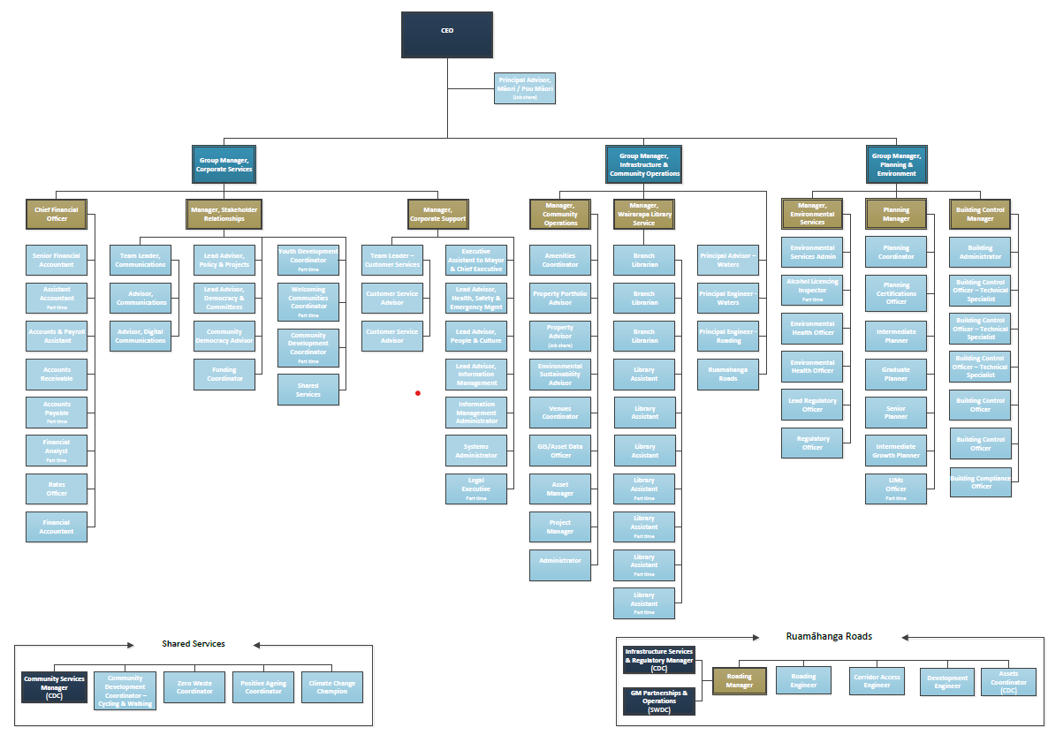

In order to ensure quality service delivery is provided, this position must have well developed relationships. These include but are not limited to:

Internal | External
Chief Executive  Strategic Leadership Team  Tier 3 Managers  Other Council staff  Mayor and Councillors  Community Boards and Committee members | Council stakeholders  Contracted service providers  Technical professionals in your field  Consultants and Contractors  Professional service providers  Auditors  The South Wairarapa community  Local Iwi groups  Neighbouring local authorities

Our Council
Our Vision: | For the South Wairarapa to be an open, energetic and unified community
Our Mission: | To be future focused, growth orientated and exercise sound judgement
Our values | We support our Mission and Objectives through living our values. These are:  - People first: Our staff, Te Tiriti o Waitangi partners and communities are at the heart of what we do. We practice respect and equality.  - Openness: We will be open in our mindset and transparent and timely in what we provide.  - Grow and learn: We listen, evolve and are open to new ideas.  - Trusted in delivery: We keep our word to deliver quality outcomes.  - Responsive and innovative: We adjust to new conditions and think outside of the box.  - Ka mua, ka muri: We look to the past to help inform where we need to go

Mō te tūnga | Role Overview
In your role as Lead Advisor – People & Capability, you will report to the Manager – Corporate Support, and work in close partnership with other South Wairarapa District Council teams to provide delivery of high-quality human resource support services and establish a culture of service excellence throughout the organisation.
Outcomes | Actions
Delivery  Context:  - Human Resources | - Work collaboratively with other members of the team to provide high level HR support to managers and staff in SWDC.  - Provide generalist employee relations advice and support that is timely, lawful, and consistent.  - Support projects and activities as well as delivering on day-today work that could include the whole range of P&C functions.  - Work collaboratively with other people and in the team to support key team objectives being achieved and share information and support proactively.  - Ensure our collateral supports the experience we want to provide and our culture.  - Provide appropriate information to other agencies for surveys/reports.  - Conduct the annual salary review process in collaboration with Managers and SLT.  - Maintain the employee sentiment survey and work with managers to ensure lessons learned are applied.  - Maintain the salary framework including the sizing of roles when appropriate.  - Undertake collective bargaining with support from Management.  - Review and develop organisational people policies.  - Promote and role model the values and goals for SWDC including good employer principles and practices and expected high standards of integrity, ethics, and behaviour in all operations of Council
Relationships | - Maintain a high trust relationship with staff and the PSA.  - Work closely alongside the Lead advisor, Health, Safety and Wellbeing, to build identify issues that act as a roadblock to our wellbeing culture and employee experience.  - Develop and maintain collaborative relationships with both internal and external stakeholders to foresee and resolve issues.  - To ensure that the Corporate Services Group and Council are always promoted in the best possible light by providing a superior customer service focused frontline.  - Maintain and develop a network of relevant contacts to ensure that communication channels are kept open.
Corporate Contribution | - Participate as a member of the SWDC Team, making a full contribution to team and organisational initiatives.  - Behave consistently with the SWDC Vision, Mission and Values  - Foster co-operation and aid communication between teams, units and groups  - Look for opportunities to improve systems, processes, and work practices – both within your own position and the organisation as a whole.  - Assist the organisation’s Emergency Management Unit in the event of a major disaster.  - Adhere to Health and Safety policies and standards and encourage all other staff to do the same.  - Attend appropriate courses to maintain ongoing knowledge and training.
Council Image | - Take every opportunity to promote a positive image of the Group and Unit and their activities.  - Contribute to the Group business plan.  - Represent the Group when appropriate at meetings.  - Provide information to customers and the public as supplied.

The key areas of responsibility above reflect the environment as it exists currently. They are not an exhaustive list and it is recognised that they will be subject to variation
Ngā āhuatanga e hiahiatia ana e Mātou | Person specification
Qualifications and Experience
- Previous experience in HR, or related field at an advisory level
- Experience of being adept at managing multiple and prioritizing the demands of a diverse range of stakeholders
- Excellent customer focus – you’ll delight in anticipating and meeting customer and Business Partner needs and be a superb relationship manager.
- Detailed knowledge of current NZ employment law and HR practices and can relate this to an organisational context.
- Experience in the analysis and presentation of information.
- High level knowledge in the relevant legislation and successful track record.
- Advanced user of Microsoft suite
- Experience working within a legislative and regulatory framework.
- Experience initiating and leading change to achieve organisation goals.

Personal Capabilities
- Demonstrated ability to form and manage high performing teams with a strong customer focus.
- Ability to analyse issues, problem solve and maintain a positive disposition under pressure.
- A high-quality relationship manager that develops a strong internal and external network.
- Delivery focused and able to work autonomously and at pace across different tasks.
- Self-disciplined and organised enough to effectively manage a large and diverse portfolio.
- Can work closely with elected officials and appreciates the political context within which they operate.
- Works collaboratively with individuals and teams to achieve joint outcomes.
- Able to write and professionally present complex information to a range of audiences.

Leadership Capabilities
Capability area | This means that Managers will
Managers will ensure that effective people leadership is your top priority | Ensure that our people know what is expected of them  Managers will have a clear set of priorities for your team. Your staff understand these priorities and what they, and the wider organisational strategy, mean for their work. Staff will periodically review whether you’ve achieved these objectives and share this with your team(s) warts and all.  Ensure our people can develop and grow  All staff in their team will have clear performance and development objectives. In setting these objectives, HOW our staff do things and HOW they behave is as important as WHAT they deliver. Coaching for Performance conversations are prioritised and held regularly, including providing prompt, clear and actionable feedback  Staff will be encouraged and rewarded for appropriate experimentation, and they celebrate both success and appropriate failure.  Any poor performance is addressed promptly, clearly, and fairly. You have a clear sense of your current and emerging capability needs and are actively following a plan to address these, including succession planning for key roles.  Ensure our people have the tools, information, and space to do their jobs  There are mechanisms for the timely dissemination of the information that staff need to do their jobs. They will delegate sign-out and decision-making appropriately and explicitly
Managers will look after your staff’s wellbeing at all times | Make the wellness of your people our primary focus. They will actively manage workloads to maintain the wellness of your people, including discussions up the line to reprioritise when necessary. There is zero tolerance of bullying and other inappropriate behaviour, and any instances are dealt with immediately, fairly and in a way that matches the scale of the behaviour.
Managers will develop a strong, high-performing and adaptive culture | Lead the development of a culture where people are supported to do their best work and to grow and develop. People will be able to raise different perspectives and concerns and challenge in an appropriate way. They know they can do so safely and that we as leaders will take their issues seriously, and people can be themselves. Diversity is encouraged and we actively use those diverse perspectives in our work.
Managers work as a collective in everything we do. | First and foremost be a member of the collective leadership team of Council, and the leader of your team second. The will ensure that behaviour, decision-making and prioritisation reflects this hierarchy. Managers will actively contribute your own time and your staff resource to collective projects as needed  They will actively contribute to collective leadership team discussions in an open and frank way to help shape our collective decisions. Once a collective decision is reached, you actively own, champion and implement that decision, irrespective of your personal views
Managers are open and honest with each other in your team and will colleagues | Raise any concerns or questions we have early, openly and constructively, and in the appropriate place and time. We will challenge each other appropriately and we react constructively, encouragingly and curiously to that challenge.  We will not raise problems or concerns without solutions or alternative suggestions. Once decisions are taken, we get on and implement in the collective interest and do not relitigate or undermine. We take a “no surprises” approach to raising any issues.
Managers engage early, frequently and effectively, and model transparency | Engage early with our partners, customers and stakeholders, internally and externally, and openly and in the spirit of seeking their contribution. We will ensure that the timing of engagement allows people to shape what we do, wherever possible.  We will model transparency in our engagements, our default position is we discuss things openly with our customers and stakeholders unless there is a very good reason not to.  We will be well planned and organised in our engagements. We will bring the results of this engagement back into Council, it is our responsibility to share it proactively and as widely as is appropriate, and we use it in our decision-making
Managers delegate, you take decisions consistent with this delegation, but you keep everyone informed. | We will keep ELT informed of anything involving the Mayor and Councillors, media and significant feedback from stakeholders and customers.  It is expected that Managers will delegate decision-making and sign-out to the lowest sensible level given the importance and risk associated with the item. It’s ok to get this wrong as long as we learn from it.
Managers do the basics well and avoid ‘own goals’. | We will follow the rules around one-up approval of invoices and take a careful but common-sense approach to sensitive expenditure. We forecast actively and to the best of our ability, and most importantly adjust these forecasts promptly when things change.  We will follow the rules around procurement, including ensuring that any exceptions to the standard processes are clearly approved. It is our responsibility to ensure all procurement has a contract and suitable documentation supporting it.  We take a risk-averse approach to identifying conflicts of interest, applying the test of how comfortable you would be with explaining why a decision is on the front page of the newspaper.
Managers will apply ‘systems leadership’ | We will lead across boundaries – departmental, organisational or sector. We will influence others rather than pull a management lever, when facing large, complex, and difficult problems. We can juggle multiple uncertainties; where no one person can find or organise the solution on their own. We work with others to make resources meet the demand, which is outstripping them, meaning that the only way forward is by involving as many people’s energies, ideas, talents, and expertise as possible.

The Values by which we work
- People first: Our staff, Treaty Te Tiriti o Waitangi partners and communities are at the heart of what we do
- Open and transparent: Everything to give and nothing to hide
- Pursue growth and learning: Actively listening and evolving. Being open to new ideas
- Trusted to deliver: Making a difference, and bringing about quality outcomes
- Responsive and creative: Adjusting to new conditions and thinking outside of the box
- Ka mua, ka muri: (Walking backwards into the future). Look to the past to inform where we need to go
The Behaviours by which we work
All staff at SWDC share these responsibilities, including me.
- Collaborate: Draw on the knowledge of others to bring about better outcomes for the customer.
- Grow: Develop ourselves and maintain the highest possible standards of professionalism. Embrace feedback and build on it.
- Being: Act with integrity and maintain consistency. Be attentive and kind to one another and embrace different perspectives.
- Add value: Through our technical knowledge, deliver the best possible outcomes for our customers.
- Plan: Be clear on how activities link together and highlight any risks.
- Do: Keep people engaged in what we do and why. Hold ourselves to account for delivery as we do with others.
- Review: Learn from mistakes. Fail fast and move on. Seek out solutions not problems. Blame as no part in our organisation.
- Inspire: Empower, support, encourage, and motivate colleagues to do their best work.
- Connected: Build strong relationships with people and are respectful and empathetic.
- Positivity: Create an empowering, safe, and inclusive social environment. Foster a strong wellbeing culture.
- Engage: Consider when to communicate. Break things down into easily understandable chunks. Take a genuine and active interest in the organisation at large. Speak out when others behave in a manner not acceptable to the rest of us.
- Celebrate: Celebrate our achievements, both individually and as a collective
Amendments to Position Description
From time to time, it may be necessary to consider changes in the Job Description in response to the changing nature of our work environment – including technological requirements or statutory changes. Such change may be initiated as necessary by the manager of the position. This Position Description will be reviewed as part of the preparation for performance planning for the annual cycle. (A review in job size and possible impact on remuneration structure of the position will only be considered where change of the position is significant (guideline: significant would typically involve a 25% change in the complexity / accountability of the role.)

My Agreement
My Name:
My Signature:
Date:

