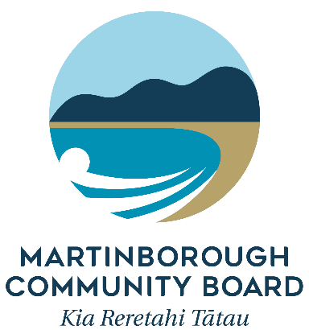

Funding Accountability Form

All recipients of funds from the Martinborough Community Board must complete this form within 12 months of the grant being paid out, or prior to any future grant application being made.

Please return the completed form to –

Committee Advisor (Grants)
South Wairarapa District Council
PO Box 6
Martinborough 5741
grants@swdc.govt.nz
1. | Name of Organisation
2. | Project Name
3. | Date of Grant
4. | Amount of Grant
5. | Please provide a summary of the project
6. | Please provide details of how the grant was spent, explaining any expenditure which was not used for the intended purpose as outlined in your grant application.
7. | How has your project provided long-lasting benefit to the Martinborough Ward community?
8. | How has your project furthered the MCB’s stated Vision and Priority Areas?
9. | Please provide details of funding received from other organisations in support of this project
10. |  | If this was not a one-off application please outline likely future funding requirements for this project.
11. |  | Bank Statements, Invoices and Receipts, Please provide copies of:  - Bank Statement with the grant fund deposit highlighted  - Bank Statements with the grant expenditure highlighted  - Invoices and Receipts for all expenditure items

Thank you for taking the time to complete this form, this allows us to carefully consider the success of our strategic grants, and, helps us to allocate our future funding to achieve the best outcomes for the Martinborough Ward community.

