Wairarapa Regional Positive Ageing Strategy Te Hōkai Nuku
Ka mua, ka muri - reflecting backwards to move forward
Update March 2023

Moving forwards - March is an action-packed month for the seniors of the Wairarapa.

Age Concern Wairarapa’s Ageing with Attitude Expo, Friday 17 March
The Expo is a showcase of services and information targeted at older people and their quality of life. The purpose of the Expo is to inform older persons about services and opportunities in the community, bring people together, showcase the value that older people bring to the community, and support young and old with planning for the future.
Trusthouse Recreation Centre from 10 am – 3pm.
Upcoming Events – Age Concern Wairarapa

Nuku Ora’s Wairarapa Senior Regional Games, Thursday 30 March
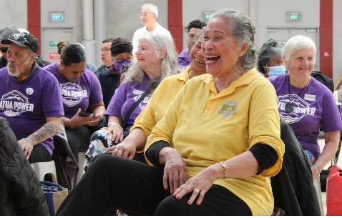
Confidence building, trying new activities, and having fun are just some of the reasons why adults aged 60+ will be attending the inaugural Wairarapa Senior Regional Games. Free to attend, attendees get to choose to ‘have-a-go’ at sports in the main gym; Badminton, Floorball, Line dancing, Indoor Bowls, Walking Netball, classes in the studio; Pilates, chair-based exercises, and aqua classes in the pool. Brain games are being organised by Masterton Library and a light lunch will be provided for participants as part of the day.
Trusthouse Recreation Centre from 10 am – 1pm.
Wairarapa Senior Regional Games 2023 | Nuku Ora

Looking backwards - achievements in 2022.
Below are some highlights from last year:
- We have seen the development of some great new services including St John’s Caring Caller, Digital Seniors Homebound Service and Age Concern’s Buddy Up programmes.
- Systems for greater working together are being put in place; Community Networks Wairarapa are hosting a quarterly Kuia/Kaumatua/Older persons online hui for organisations working with older persons and the paperwork is in place to enlarge the Group that advises on the Positive Ageing Strategy. Both are designed to ensure that issues related to older people are being discussed and tackled. Also, the groups working in the older persons and digital space are beginning to work together.
- Submissions on the Greater Wellington Regional Council Fare Review by Carterton and South Wairarapa District Council highlighted the issue with the Gold Card and the train timetable. We now have a commitment by the Regional Council to look at this problem.
- Accessibility of Council venues continues to be front of mind with South Wairarapa District Council auditing three of its venues, Masterton installing the electronic doors at the Trusthouse Recreation Centre, and both Carterton and South Wairarapa purchasing accessible park furniture.
- The three Councils agreed to apply for membership of the World Health Organisation’s Global Network for Age Friendly Cities and Communities. It means access to international resources and research and a greater awareness of our work here in the Wairarapa.
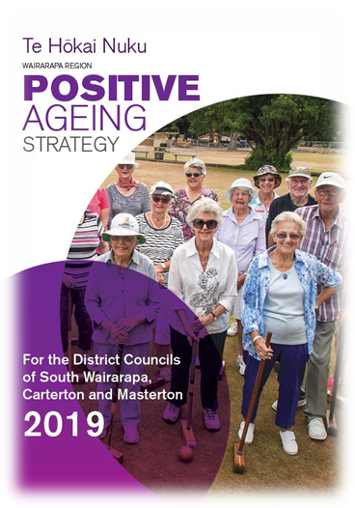
If you have any questions or would like to get in touch, please contact Lisa Matthews, Regional Positive Ageing Strategy Co-ordinator lisa@cdc.govt.nz or 027 444 1887.

The aim of the Positive Ageing Strategy is to improve and integrate council services for older people to help them lead valued, connected and fulfilling lives. You can read the full Strategy on your Council website.

