TAUPO LAND DISPOSAL 25 YEARS ON

Kevin Sears, Operations Manager Three Waters, Taupo District Council (New Zealand)

ABSTRACT

Taupo District Council (TDC) is a small council in New Zealand that has several communities of differing size scattered around the shores of Lake Taupo. The communities’ demographics are primarily Maori & Pakeha. The district has a strong Maori heritage and culture and these strongly influence the decisions of Taupo District Council.
One of these cultural factors is the thinking that “All human waste should go to land”. Water or “Wai” is life generating and has spiritual significance for Maori. Therefore interaction between Wai and human waste in particular is contrary to this fundamental principal. This has influenced Council’s decisions to dispose of Wastewater Effluent via land disposal.
All of TDCs eleven Wastewater Treatment Plants (WWTP) discharge to land with only one exception. This presentation concentrates on the Land Disposal of the Taupo townships treated effluent and this journey over 25 years. Taupo town is the largest of these communities with a population of 22,000 and approximately 50,000 over the summer holiday period.

1.0 INTRODUCTION

The Taupo Land Disposal System (LDS) has become the Flagship for land disposal of treated effluent in New Zealand. If another council is considering land disposal the Taupo LDS has become “a must see”. Several times a year tour parties from different councils or organisations arrange to visit this site. This is due to it being a very successful tertiary treatment option that is culturally and resource consent compliant. This does not mean there have not been challenges to overcome. Just that as each challenge has risen and been resolved the tenure and status of this land disposal system has been raised and is now seen as a successful example and long-term solution to effluent disposal in New Zealand.

The Taupo WWTP was constructed and commissioned in 1974. It is a conventional plant with primary sedimentation, trickling filters, secondary sedimentation and anaerobic digestion and dewatering of solids. The treated effluent discharge from the plant in those days was directly to the Waikato River. This is the longest river in New Zealand and its source is Lake Taupo and it reaches the coast just south of Auckland city. This was not culturally acceptable and over time the Council became uncomfortable with this approach and in 1993 it was decided to investigate and plan to dispose of the effluent to land.

In 1994, 150 hectares of farm land was purchased just outside of the town and an irrigation system was established using Hunter Pop Up Sprinklers. A 50m none irrigation buffer zone was required around the outside of the farm and this reduced the irrigation area to 136 hectares. A new pump station was built at the WWTP and a rising main was laid to the farm. This rising main is about 4km long. TDC sowed the pasture with a rye grass species that was recommended for irrigation by Agresearch & Development. The LDS farm was commissioned in 1995.

The plan was to run a “Cut & Carry” operation. This means the grass would take up the applied nutrients and would be harvested into silage bales and sold outside the catchment of Lake Taupo to farmers for stock feed. This effectively removes the nutrients from the catchment. This currently works well but took some time for the bales to be accepted by farmers. The bales were sold well below the market value to attract people to try them. Now we have a demand for them that is greater than our supply.
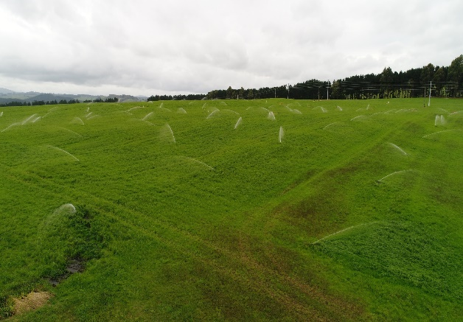
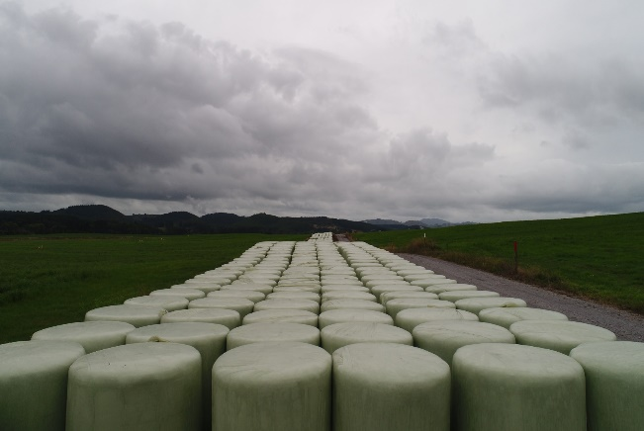

Figure 1: Pop Up Sprinkler Irrigation. Figure 2: Silage Bales ready for sale.

In the early days, the average daily flow was about 4000m3 per day or 1.5 million m3 per year. This equals an application depth for the irrigation of 29.5mm per day. The consent limit was 35mm per day. Over time as the town grew this became 40mm per day application or 5440m3 per day. This meant by 2005 TDCs hydraulic Resource Consent limits had been breached and TDC had to consider options to resolve the breach. Nitrogen application for this site was also limited to 640kg/ha/yr but at this stage, TDC had not breached this limit.

2.0 DISCUSSION

Several treatment options were considered to remove nutrients and either apply for a consent to discharge back to the Waikato River or increase the application rate for the irrigation based on the nutrients removed. In addition, the option to expand the current irrigation LDS based on its current state to cater for the growth in volume was a consideration.

Due to the strong cultural influences on TDC and the direction previously set by council the upgraded treatment options became less preferred relatively quickly and expansion to the irrigation farm in its current form was the preferred direction. The decision was made in 2007 to continue with Councils philosophy of disposal to land.

The district was experiencing rapid growth and a new road called the Eastern Taupo Arterial highway was being planned as part of this growth. It’s path went through the original LDS site meaning the effective irrigation area was reduced to 120 hectares compounding the over loading. With a desire to secure a long term (50 years) land disposal option for TDC a second farm was purchased at a cost of $8.6 million. This farm was 350 hectares in total and from this a further 120 hectares of land was prepared for irrigation. The balance of this land is leased to a farmer until it is needed. Due to the difficulty and expense in maintaining the pop up sprinkles at the original LDS, TDC decided to use Centre Pivot Irrigators. This LDS system was commissioned late 2008 and has a consent limit for nitrogen of 550kg/ha/yr and a hydraulic loading limit of 45mm per week or 15mm per day.

The cost to establish the Centre Pivot Irrigation on 120 hectares was $7million.

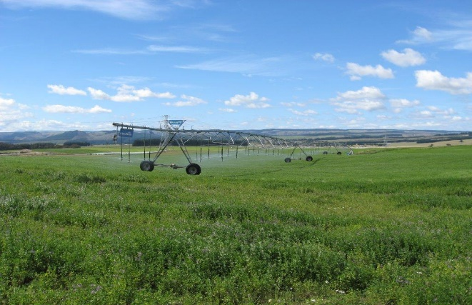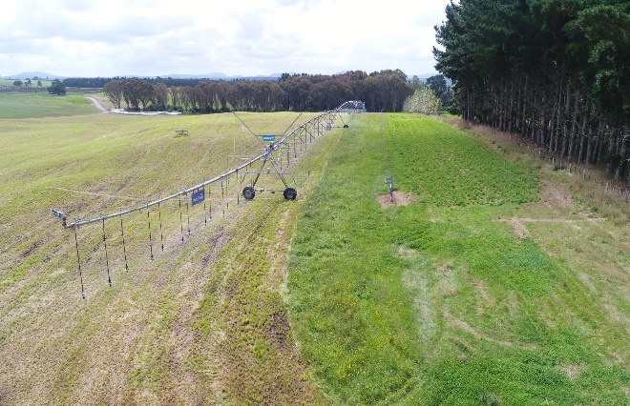
Figure 3 & 4: Centre Pivot Irrigators at Taupo’s Land Disposal Site

2.1 Effluent Quality

The quality of effluent from the Taupo WWTP is typical for the type of treatment it employs. The plant does not have active nutrient removal processes nor does it have any form of disinfection or sterilisation. Below is some typical parameters for the effluent quality;
- Total Nitrogen = 40 – 50ppm
- NH4-N = 35 – 45ppm
- COD = 90 – 130ppm
- Ecoli = 350,000 – 480,000
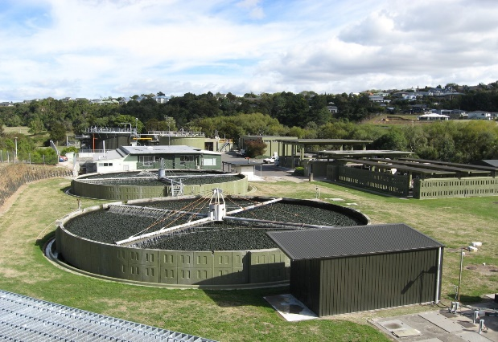
Figure 5: Taupo Wastewater Treatment Plant

2.2 Current Crop Production & Sales

TDC currently produces between 17,000 and 18,5000 bales per year off the LDS farms. This includes Lucerne that has been planted on non-irrigated buffer zone land and some surplus land that has not been leased out. The income from these bales is $1.2 to $1.4million per year. The total opex costs to run the farms is $1.9million per year. So the resale of the crop only offsets the cost by about two thirds. This is favourable compared to the opex costs to run a tertiary nutrient removal plant and discharge to the river.

The irrigated bales are restricted from use for lactating dairy animals, but maybe used while these animals are not lactating i.e. in winter. This fits well with when farmers need feed and with TDCs Lucerne production being suitable for lactating diary animals this provides an all year round supplementary feed source. TDC has become one of the largest supplies of supplementary feed to the farms in the central North Island.

A random selection of bales from each harvesting block and cut are core sampled and this is sent to a certified laboratory for testing for Ecoli, Listeria, Metalisable Energy (ME) Dry Matter (DM) Protein and Digestibility. Based on these results the bales are graded into 3 different groups per crop species. This is done by averaging the ME & Protein levels and confirming Dry Matter levels are acceptable.

Below is a table showing grade and price.

Table 1: Bale Grading

Crop Type | Ave ME & Protein | Dry Matter | Grade | Price + GST / bale
Lucerne | > 15 | > 35% | Premium | $95
Lucerne | 12.5 – 14.99 | > 30% | A Grade | $85
Lucerne | < 12.5 | > 30% | Low Grade | $75
Rye Grass | > 12 | > 35% | Premium | $70
Rye Grass | 9 – 11.99 | > 30% | A Grade | $65
Rye Grass | < 9 | > 30% | Low Grade | $60

2.3 A New Venture in Land Disposal – Vermicomposting of Biosolids

In February 2017 TDC ventured into Vermicomposting (worm farming) for the disposal of its biosolids. The plan is to mix TDC’s biosolids, which is high in arsenic, with waste pulp and paper fibre, which has no arsenic, to make a good food source for worms. As the worms consume the biosolids fibre mix they break it down to an Aa grade biosolid which effectively is a nutrient rich soil conditioning agent or fertiliser for land.

The biosolids/fibre mixture is laid out in windrows about 20 metres wide and 0.5 of a meter high and as long as practical. The worms migrate through the windrow over a 12 to 18 month period breaking it down. Once they have done their job there are no pathogens left in the biosolids and the reduction of arsenic level to below the Maximum Acceptable Value (MAV) happen by dilution with the fibre.

When each windrow is completed a small gap is left and then a new windrow is laid out alongside the old windrow. Worms can migrate up to 100 metres a day and so will migrate from one windrow to the next to get to more food. This can be speed up by seeding the pile with some Vermicast with worms in it. A good health food source for the worms will mean they will breed in the mixture and future seeding is not required.

The final product is tested by a certified laboratory to ensure it meets the Aa grade standard and then is screened to remove any plant matter that has grown on the windrow and any foreign matter like wood of plastic that the worms haven’t broken down. Then the final product is spread onto the surplus buffer land with the Lucerne crop as a fertiliser.

TDC has just spread its first batch of Vermicompost onto its own land. It is expected that a significant reduction in purchased fertiliser will be achieved by using the Vermicompost.
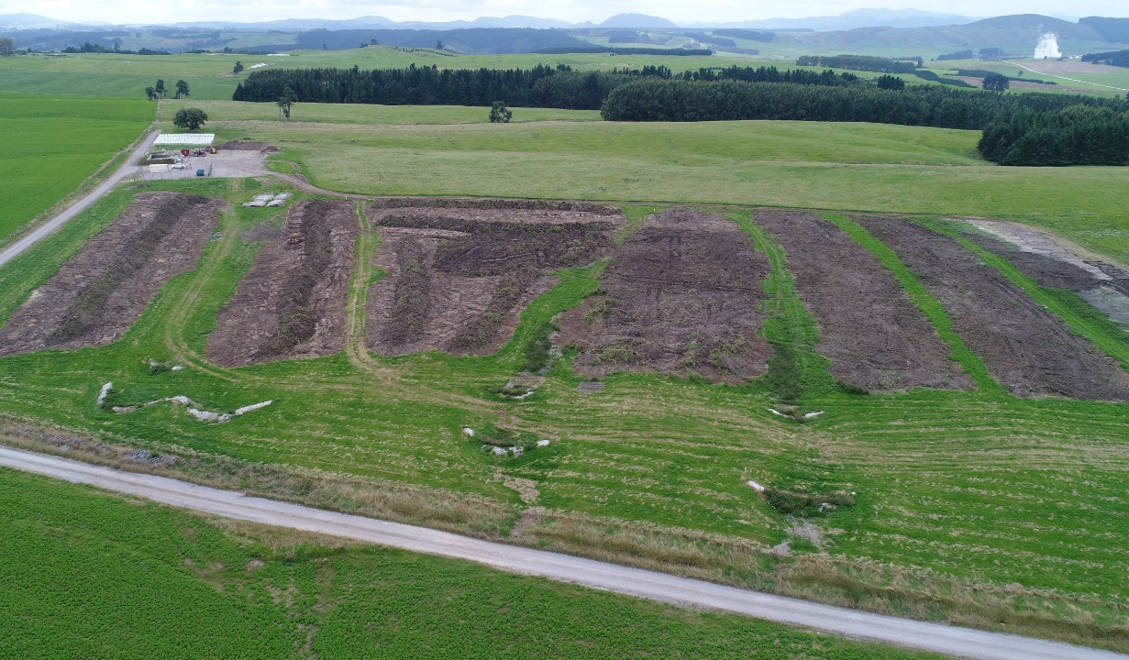
First windrow of biosolids & fibre from WWTP
Third windrow from Maturation pit
Second windrow from Maturation pit
Figure 5: Vermicomposting (Worm Farm) at the Land Disposal Site

3.0 CONCLUSION

The land disposal of treated wastewater effluent has been an effective tertiary treatment and disposal method for the Taupo District Council. While early on, some thought that it was solely a politically correct and culturally friendly solution it has proven its self to be more than this. The baleage product has become a sort after feed source with high demand when used in the appropriate way, and they are no longer known as the “SH.T” bales but are respected in the farming community as a valuable feed source that are well produced and weed free.

The initiative to grade the bales in to three grades to optimise the potential income has increased revenue for TDC and given farmers the ability to select the type of feed they require to meet their need at the appropriate cost.

The addition of the Vermicomposting process to the LDS is expected to prove itself a long-term solution to biosolids disposal. It has a feel good factor about it from a sustainable recycling of a waste product viewpoint and has the potential to reduce significantly TDCs requirements for purchased fertiliser. Previously the biosolids were disposed of at the Landfill which was a waste of a source of nutrients and also filled the Landfill quicker than was necessary.

4.0 ACKNOWLEDGEMENTS

I wish to acknowledge the work done by Colin Little and Shannon McMillan of Taupo District Council in helping me by collecting photos with a drone. Also thankyou to the Operations Head of Department Kevin Strongman of Taupo District Council for allow me to the time to attend the WIOA Conference to present this paper.

5.0 REFERENCES
Nil

