Quarry Q/A
Process and key dates
- Application received - 27 October 2020
- Further information requested - 5 November 2020 (specialist reports requested)
- Public meeting held - 9 November 2020
- Specialist reports received - 23 April 2021
- Peer reviews of Noise and Traffic report begin - 28 April 2021
- Peer reviews completed - 12 July 2021
- Further acoustic information requested - 14 July 2021
- Applicants updated Noise assessment received – 12 December 2021
- Applicant provides three written approvals – 17 December 2021
- Legal opinion obtained – 27 January 2022
- Full and updated applicant received from applicant – 17 February 2022
- Decision granted – 4 March 2022
What has been consented?
Extraction, processing, crushing and stockpiling of aggregate.
The full process includes:
- Removing topsoil and placing in windrows to be spread back on the site after work is complete
- Excavating the aggregate material beneath the topsoil
- Screening the excavated soil to separate different grade aggregate
- Crushing aggregate
- Stockpiling aggregate for carting from the site
- Carting aggregate from the site
- Remediation of the extracted strips (unwanted fines are spread as a subsoil, the topsoil is spread on top, and the completed area is sown in pasture)
- Hours of operation are limited to 0800-1700 Monday to Friday (excluding public holidays).
The extraction will work in strips of approximately 30m wide and 180m long. This will be determined by the shape of the paddock worked within. Once one strip is complete another will begin alongside it. Once aggregate is extracted, the topsoil is respread and regrassed at the next available opportunity, i.e., conditions when grass seed will strike and persist.
The crusher is staying within one location on the site, this is on the lower terrace and will be surrounded by bunds.
Processing will only occur in certain areas and behind 3m bunds (white line)
Extraction will take place within certain areas with setbacks from adjoining properties to the north and south (blue line)

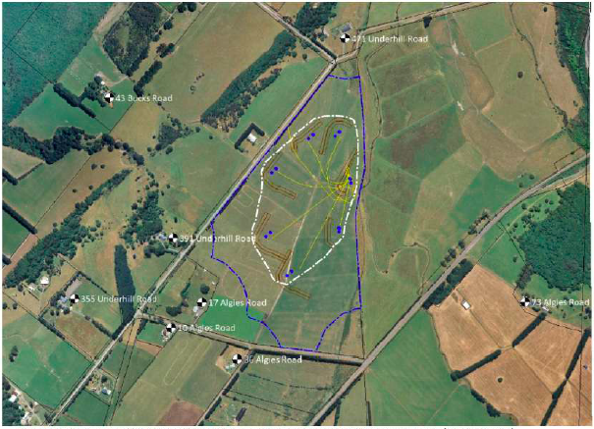
What did GWRC consent?
A consent from Greater Wellington Regional Council (GWRC) was granted to extract aggregate from the site over a 10-year term. Reference number WAR210053.
As a regional council GWRC manages effects on the environment e.g. water and air quality.
Both consents will expire 24 August 2030.
Roading
The consent holder provided an independent traffic assessment in support of the application. Council commissioned this report to be peer reviewed by an external consultant. The peer review aligned with the findings of the applicant’s report. Council’s Roading engineer also reviewed both reports and conditions were imposed to reflect the experts’ recommendations.
Conditions of consent require the road entrance to be upgraded and widened and any damage to the road berms to be repaired.
Truck movements are limited to 8:00am – 5:00pm Monday to Friday (excluding public holidays)
What is happening to manage dust?
Both GWRC and SWDC have roles in managing the effects from dust. Conditions of consent have been included in both consents which require the consent holder to actively manage dust so that any emissions do not cause nuisance or offence beyond the boundary of the site. Given these controls, it is not anticipated that the operation of the site will generate any health effects.
Won’t it be noisy?
A change in the noise environment is not necessarily considered an effect on the environment.
The consent holder provided an Acoustic Report in support of the application. Council commissioned this report to be peer reviewed by an external consultant. The consent holder underwent further testing of the equipment on the site which found that noise did not exceed the permitted rural zone standards beyond the area identified.
The assessments considered if any parties were likely to experience noise greater than provided for in the District Plan. Any parties that were deemed affected have given their written approval to the proposal.
Conditions of consent have been included which require a Noise Management Plan to be undertaken and complied with. These include but are not limited to:
- Noise mitigation, including the bunding at each processing location as discussed within this report
- Limiting the hours of the processing of aggregate to within the stated times of 8:00am to 5:00pm Monday to Friday
- Maintenance and/or upgrading the site access route and any other vehicle paths that are developed on the site to be kept free of undulations, potholes etc. to minimise truck noise
- Minimising the banging of tailgates
- Careful placement of the processed material (particularly the first loads) into the truck and trailer trays, rather than “dumping” from a height above the tray
- Ensuring that equipment is properly maintained
- Mitigation of track squeal from tracked equipment (may include tensioning and watering or lubricating the tracks regularly)
- Avoidance of tonal reversing or warning alarms (suitable alternatives may include flashing lights, broadband audible alarms or reversing cameras inside vehicles)
- Mitigation measures
- Community liaison (providing contact details for complaints)
- Noise monitoring. This would include measurement of aggregate processing noise, received at selected representative receiver locations. Noise measurements would provide PJ Warren Earthmoving Ltd with information regarding processing methodology; identify any processes that are unnecessarily noisy; provide confidence to potentially affected residents that their concerns are being considered; and identify compliance or non-compliance with the relevant noise limits
- Staff training.

Monitoring
The conditions require the applicant to monitor noise and advise council of any complaints. Council under its functions can monitor the site for compliance with its conditions of resource consent.
Why wasn’t I consulted?
In processing a resource consent, Council must determine who are considered affected parties based on the tests provided in the Resource Management Act, the District Plan and supporting expert opinion. An assessment was undertaken under s95D of the Resource Management Act 1991. This assessment considered traffic, noise and vibration, dust and other effects, along with the expert reports. The evidence in the finalised peer-reviewed expert reports did not find that there would be effects on the broader environment arising from the proposal. That and other considerations meant that public notification was not required or appropriate. Any parties identified in the technical reports as potentially affected have supplied their written approval to the proposal.
What if I disagree with the decision - can I appeal?
You will need to seek independent legal advice on any options available to you.

