Featherston Masterplan
Questionnaire

The Council is developing a masterplan for the future of Featherston (see map below of the masterplan study area). The masterplan will be a plan to integrate transport, housing, recreation reserves, infrastructure, community facilities, land use patterns, iwi and community aspirations.

We are seeking your views on what you would like for the future of Featherston. A public workshop will be held online via Zoom on the 30th of March 2022. Alternatively, completed forms can be delivered back to the library or scanned and emailed to spatial-planning@swdc.govt.nz by 5th April.
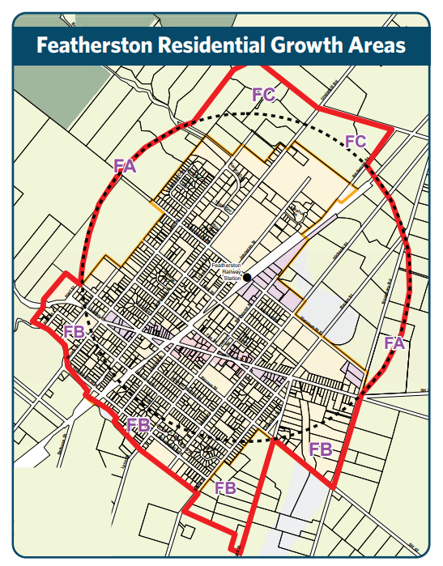
Personal Details
Your name and feedback will be in public documents. All other personal details will remain private.
Name:…………………………………………………………………………………..
Post Address………………………..
Email…………………………………………………………………………..
Phone……………………………..

Gender:

Age:
15-20
21-30
31-40
41-50
51-60
61-70
70+

Iwi/hapu affiliation

Organisation (only if authorized to submit on behalf of an organization, one submission per organization)
The Privacy Act 2020 applies when we collect personal details. Any details that are collected will only be used for the purposes stated on this form. You have the right to access and correct any personal information we hold.

Questions:

Question 1. What would you like Featherston to be like in 10 year’s time – describe your vision for Featherston.

Question 2. Featherston is growing, and the masterplan will be looking at ways to accommodate more residents and businesses. What character and qualities would you especially like to see retained?

Question 3. What amenities would you like to see developed or enhanced in Featherston as it grows and changes?

Question 4. What sort of housing do you think Featherston needs now and in the future?

Question 5. What do you think of the current town centre? Would you like to see more commercial and less industrial activities along the main street?

Question 6. Have you any other comments or suggestions you would like to make to help shape the future of Featherston.

