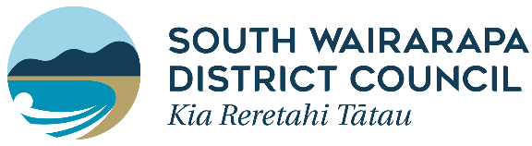
South Wairarapa District Council
2020/21 Community and Youth Grant Accountability Form

All recipients of grants from the South Wairarapa District Council (SWDC) must complete this form within 12 months of the date of the grant being paid out, or prior to any future grant application being made.

Failure to complete and return this form will prevent you/your organisation from consideration for further grants in the future.

Please return the completed form to:
Steph Dorne
South Wairarapa District Council
PO Box 6
Martinborough 5741
steph.dorne@swdc.govt.nz

Organisation’s name:

Project Title:

Location and date of project:

Applicant’s name:

Amount received for project:

Details of project:

Expenditure:
Please give details of how the money was spent (attach a spreadsheet of expenditure, if appropriate).

How did your project benefit the wider community in South Wairarapa?

What were the key successes of your project?

What did you learn from the project?

What are the longer-term gains for the South Wairarapa community as a result of your project?

Was your application a one-off or do you see the need for further funding in the future?

Which other organisations supported you in your project?

Report Completed by:
Name:
Signed:
Address:

Designation:
Date:
Phone:
Email:

