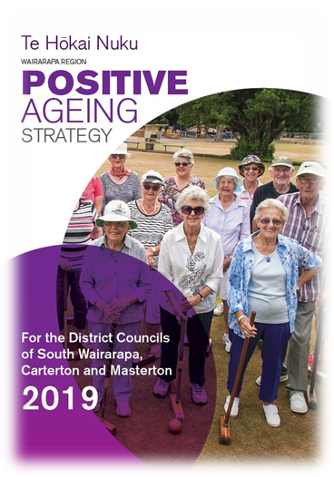
Wairarapa Regional Positive Ageing Strategy Te Hōkai Nuku
Update March 2022
As I write this, my 73 year-old partner is off to a meeting. However, generally we are staying mostly very quietly at home while Omicrom rages around us; the grandchildren aren’t coming to stay, and we are definitely less social.
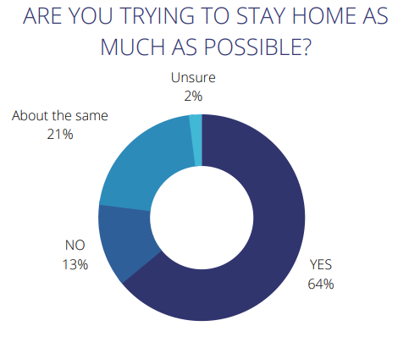
A recent survey done by Age Concern Wellington, found that two out three seniors (64%) are staying home as much as possible. Only 20% of respondents had not changed their behaviour at all. Levels of concern at going out were rated - Respondents were asked to rate between 1 – not concerned and 10 - very concerned, the average score for respondents was 5.8.
Loneliness was already recognised as an issue for older persons prior to Covid- 19 with the Wellbeing statistics: 2018 (Statistics New Zealand) showing that 11.2% of people over 65 felt lonely all, most, or some of the time. Studies also show that loneliness is bad for your health – as bad as smoking! It has also been linked to the increased likelihood of entering rest home care.
But enough of the doom and gloom - there are some great new services that are starting up in the Wairarapa that our older people can use to help combat loneliness and feelings of isolation.
Digital Seniors Home Coaching service
Digital Seniors provide range of services to help seniors learn how to use devices and digital tools and to resolve their technology concerns. In April, they are launching a new Home Coaching programme. This is designed to reach senior Wairarapa residents who are more home based bound and through personal circumstances find it more difficult to leave their homes.
The programme is free, and participants will receive a visit from a Digital Seniors coach once a week for 6 weeks. Homebound seniors aged 65+ that would like to participate in Home Coaching once it officially launches can find out more and pre-register by calling 0800 373 646. All Digital Seniors coaches are police checked and fully vaccinated.
St John’s Caring Caller Programme

Caring Caller connects people who need a friend with people who have time to listen and chat. It is based on the belief that having someone ask about your day can make all the difference to how you’re feeling. It is a confidential, volunteer-based programme where clients are matched with a suitable caller. If you would like someone to call you, know someone who would like a regular phone call or are interested in becoming a Caring Caller, then contact St Johns on 0800 000 606 or go online.

Congratulations to both St Johns and Digital Seniors for bringing these great new services to the Wairarapa.

Know your Neighbours

The three Wairarapa Councils recently joined up to remind people the importance of knowing your neighbours. Now is the time to think about who your key contacts are – use the postcard below to grab their phone numbers.

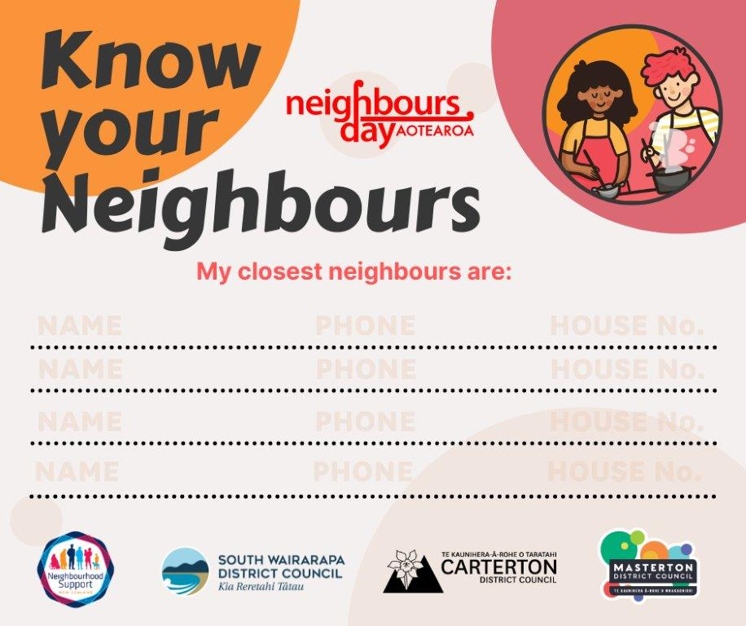
If you have any questions or would like to get in touch, please contact Lisa Matthews, Regional Positive Ageing Strategy Co-ordinator lisa@cdc.govt.nz or 027 444 1887.

Positive Ageing Strategy
The aim of the Strategy is to improve and integrate council services for older people to help them lead valued, connected and fulfilling lives. You can read the full Strategy on your Council website.

Covid-19 Research | Age Concern Wellington (acwellington.org.nz)
https://www.stats.govt.nz/information-releases/wellbeing-statistics-2018#:~:text=81.1%20percent%20of%20New%20Zealanders,of%208.2%20out%20of%2010.
https://www.ageconcern.org.nz/Public/Info/Research/Loneliness_and_Social_Isolation_Research. aspx
https://www.stjohn.org.nz/what-we-do/community-programmes/caring-caller/

